1. **PLP Basis server details**

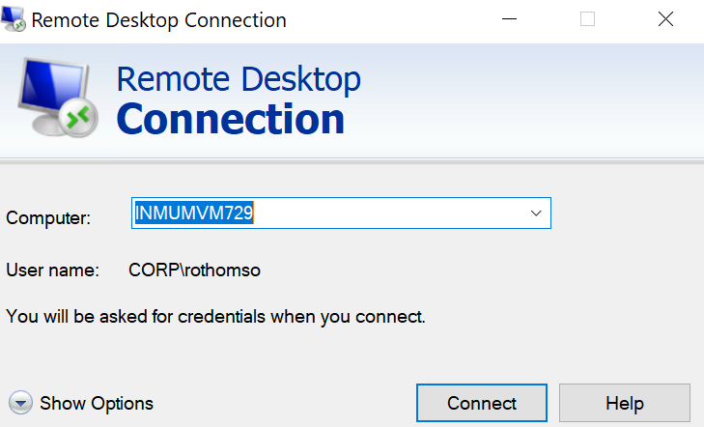

1. Use RDP to connect to server INMUMVM729 as shown above
2. Login using your corp ID and password
3. For more details of the server , see below:

Service Functionnal name: INMUMVM72914105

Here are the necessary informations to log VM:

* **Virtual Machine hostname: INMUMVM729**
* **Virtual Machine IP address: 10.246.88.246**
* **Virtual Machine MAC address: 00:50:56:9e:cf:28**
* **Virtual Machine root/administrator password: null**

1. **For SAP Connection( To be tested only BU SME / TRAINERS)**

When you login to PLP server with your corp id, there is already a system installed with SID – TR1.

User id in SAP client 001 – Trainer and Password is Welcome123